Screenshots or program listings must be copied into appropriate cells in the following table.
Save this evidence document as evidence_ followed by your centre number_ candidate number. For example: evidence_ zz999_9999 and insert your name, centre number and candidate number into the header above.
Examiners must be able to read the contents including any screenshots without the use of a magnifying glass. Answers that are not readable or missing will not be awarded any marks.
Save this evidence document at regular intervals, for example, every 10 minutes.
Question 1
Part 1(a)
def Unknown(X:int, Y:int) -> int:
if X < Y:
print(X + Y)
return(Unknown(X+1, Y)* 2)
else:
if X == Y:
return 1
else:
print(X + Y)
return (Unknown(X-1, Y) // 2)

Part 1(b)(i)
print("X: 10, Y: 15")
print(Unknown(10,15))
print("X: 10. Y: 10")
print(Unknown(10,10))
print("X: 15, Y: 10")
print(Unknown(15,10))

Part 1(b)(ii)
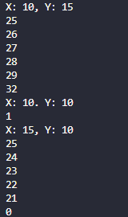

Part 1(c)
def IterativeUnknown(X: int, Y: int) -> int:
if X < Y:
for i in range(X+Y, 2*Y):
print(i)
elif X == Y:
pass
else:
for i in range(X+Y, 2*Y, -1):
print(i)

return int(2**(Y-X)//1)

Part 1(d)(i)
print("X: 10, Y: 15")
print(IterativeUnknown(10,15))
print("X: 10. Y: 10")
print(IterativeUnknown(10,10))
print("X: 15, Y: 10")
print(IterativeUnknown(15,10))

Part 1(d)(ii)
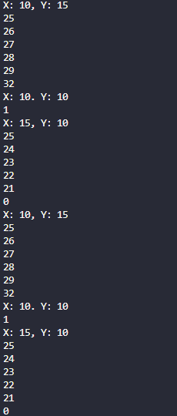

Question 3
Part 3(a)
ArrayNodes = [[None for _ in range(3)] for _ in range(20)] #2d array of type integer 3 col 20 row
RootPointer = -1 #int
FreeNode = 0 #int

Part 3(b)
def AddNode(ArrayNodes: list, RootPointer: int, FreeNode: int):
print("Enter the data")
NodeData = int(input(""))
if FreeNode <= 19:
ArrayNodes[FreeNode][0] = -1
ArrayNodes[FreeNode][1] = NodeData
ArrayNodes[FreeNode][2] = -1
if RootPointer == -1:
RootPointer = 0
else:
Placed = False
CurrentNode = RootPointer
while not Placed:
if NodeData < ArrayNodes[CurrentNode][1]:
if ArrayNodes[CurrentNode][0] == -1:
ArrayNodes[CurrentNode][0] = FreeNode
Placed = True
else:
CurrentNode = ArrayNodes[CurrentNode][0]
else:
if ArrayNodes[CurrentNode][2] == -1:
ArrayNodes[CurrentNode][2] = FreeNode
Placed = True
else:
CurrentNode = ArrayNodes[CurrentNode][2]
FreeNode += 1
else:
print("Tree is full")

return FreeNode, RootPointer

Part 3(c)
def PrintAll():
for i in range(FreeNode):
LP = ArrayNodes[i][0]
DT = ArrayNodes[i][1]
RP = ArrayNodes[i][2]
print(f"{LP} {DT} {RP}")

Part 3(d)(i)
for i in range(10):
FreeNode, RootPointer = AddNode(ArrayNodes, RootPointer, FreeNode)
PrintAll()

Part 3(d)(ii)
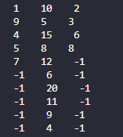

Part 3(e)(i)
def InOrder(currentNode):
global ArrayNodes
if currentNode != -1:
InOrder(ArrayNodes[currentNode][0])
print(ArrayNodes[currentNode][1])
InOrder(ArrayNodes[currentNode][2])

Part 3(e)(ii)
